Assignment 4- Final Website Design

IASC 1P02

Leesha Young-Wood

ID:6024996

Date: December. 2nd , 2019

I have created 5 webpages for my website design. Here are links to each one:

<https://ly15qk.github.io/IASC1P02-2019/final%20assignment/home.html>

<https://ly15qk.github.io/IASC1P02-2019/final%20assignment/about.html>

<https://ly15qk.github.io/IASC1P02-2019/final%20assignment/adoption.html>

<https://ly15qk.github.io/IASC1P02-2019/final%20assignment/grooming.html>

<https://ly15qk.github.io/IASC1P02-2019/final%20assignment/appointment.html>

**Rationale:** I have decided to make a webpage about a made up company called Paws, which does dog grooming and adoption. I chose this topic because it is a topic I am very passionate about. Each page consists of the same header and footer to keep consistency throughout my website. The header consists of a logo on the left side and the title “Grooming and Adoption” left-aligned right next to the logo. The header also contains a menu drop down menu on the right side with the options “home, about, adoption and grooming”. From the grooming page you can then get to the ‘appointment’ page. The footer includes the companies contact information, along with a twitter image that takes the user directly to a twitter page ‘@paws’ when clicked on.

On the ‘Home’ page I have decided to include a little blurb about what the company does and why people have dogs. Under that follows with 2 columns both small and large dogs listing the 8 most popular with pictures of each and their average weight and lifespan. Lastly, this page includes a checklist allowing users to see if they are able to answer yes to all the statements listed. These statements are useful for knowing whether you are ready to adopt or not.

On the ‘About’ page I have included some content about what the company does and why having a dog is good for you. I also included an image underneath that represents the benefits of having a dog!

On the ‘Adoption’ page I chose to post the dogs currently available for adoption. I used 4 columns for the 4 different dogs and included a picture and text under each with a little description about the dog. Then underneath the columns there is a little thank you message for choosing to adopt. I have also chosen to include a YouTube video that shows how a compilation of how happy adopted and rescued dogs are!

The ‘Grooming’ page includes a paragraph about why we offer our grooming services. Followed by 3 columns, including pictures demonstrating each treatment type and a mini paragraph under each that describes what is included. Which is then followed by the treatment price. Under the columns there is a button I have included that takes you directly to our appointment booking page.

Lastly, the ‘Appointment’ page includes fields where the user can input their name, email, puppies name, and appointment time preferred. The appointment time uses a drop down calendar where users can simply click the date they would like or they can manually enter in the YYYY-MM-DD Time HR:MIN. Following the fields is a reset and book now button, the reset button resets all fields to their factory setting and the book now submits the booking.

There were 3 colours I chose to use throughout my website. These were #24A4B0,

#28D23D and #3559BD. The colour scheme I chose to use was analogous, as these are all colours that are adjacent to each other on the colour wheel. These colours are often found to be pleasing to the eye and together give a bright and cheery effect. I thought these colours went well with the ‘dog’ theme, as green and blue are the main colours I think of when thinking about dogs or dog collars. I chose to make the green colour the background of my header and footer. I wanted this to be my main colour and didn’t want my whole webpage backgrounds to be coloured.

I decided to keep black as my paragraph content font-colour throughout my entire website as it is not distracting and easy to read. The entire website also uses the font: calibri as it is also easy to read. For important titles or headings, I chose to use the two blue colours. The darker blue for the more important large headings and the lighter blue for sub headings. I think these grab users’ eyes to the different sections of the website and allows for separation between parts. For less important text I used for sizes around 16-18 and for the larger headings they were either <H1> or font-size:20px.

Regarding C.R.A.P, I attempted to make my website as visually appealing as I could. Regarding contrast, I used the colours to state that the items were different or a new section/topic was starting. These colours added contrast to the page and made it more attractive for the user. I avoided using colours and images that were too similar as this would be distracting and boring. For repetition I used the same header and footer for every single webpage, this worked to unify my whole website and make it clear that all the webpages still belonged to the same website. As well as keeping colours, fonts and sizes consistent. The alignment was also consistent across all pages. The only items that were ‘center-aligned’ were the pictures in the 3-and 4-way columns. If they were left aligned it would have looked off. All other content on all webpages had left align to keep consistency with the alignment. In the header and footer the menu drop down and twitter link were right aligned to make it obvious that they were there and were important. Any text in column boxes or divs were always left aligned. Lastly, for proximity all items that were related to each other are seen as a group. Items that are different or new sub-topics were separated by a space or different coloured heading.

MOCKUP IMAGES:

**Home Mockup:**

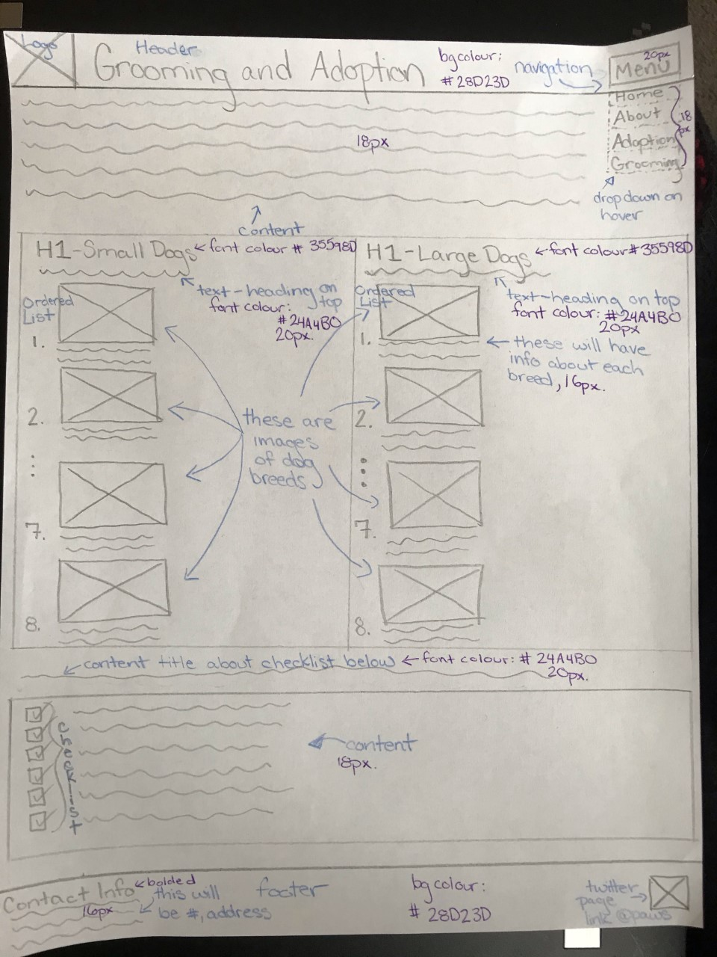

**About Mockup:**

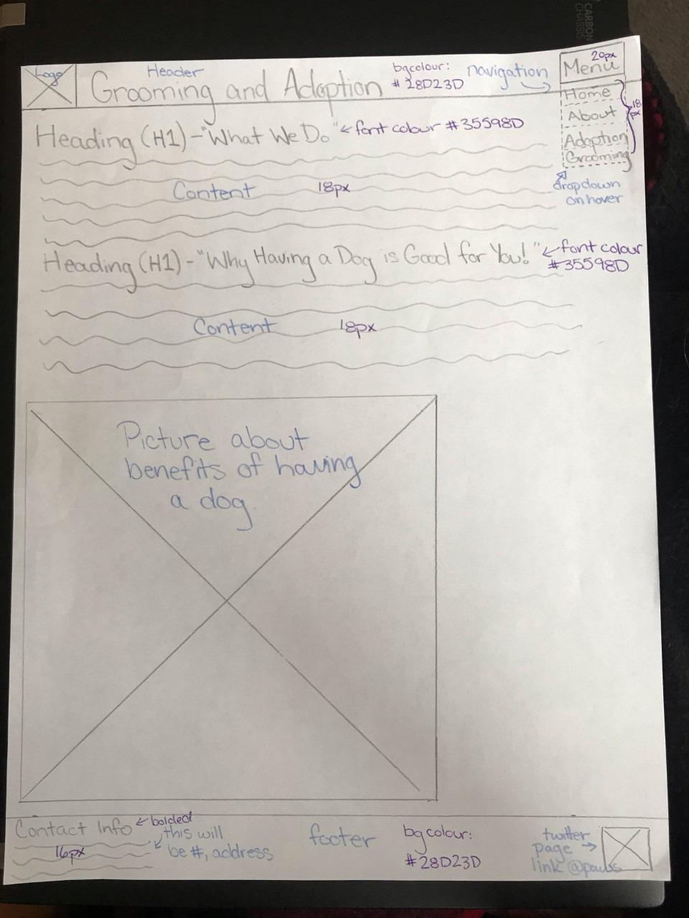

**Adoption Mockup:**

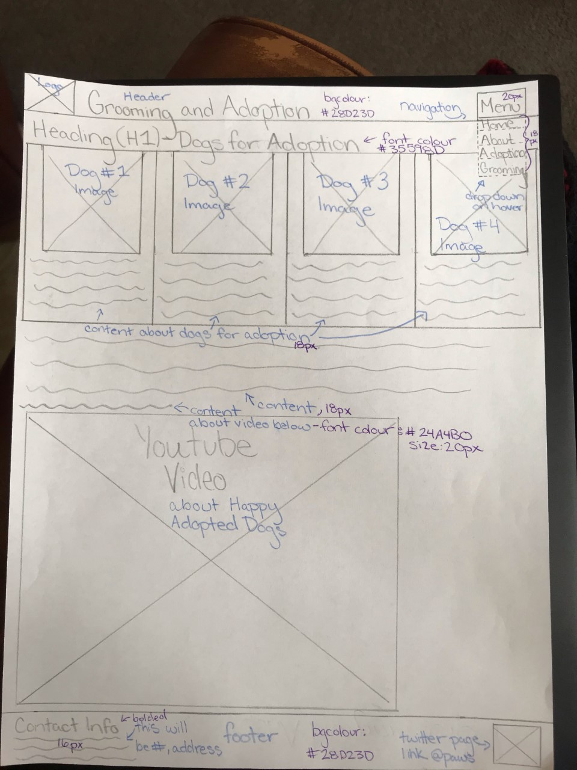

**Grooming Mockup:**

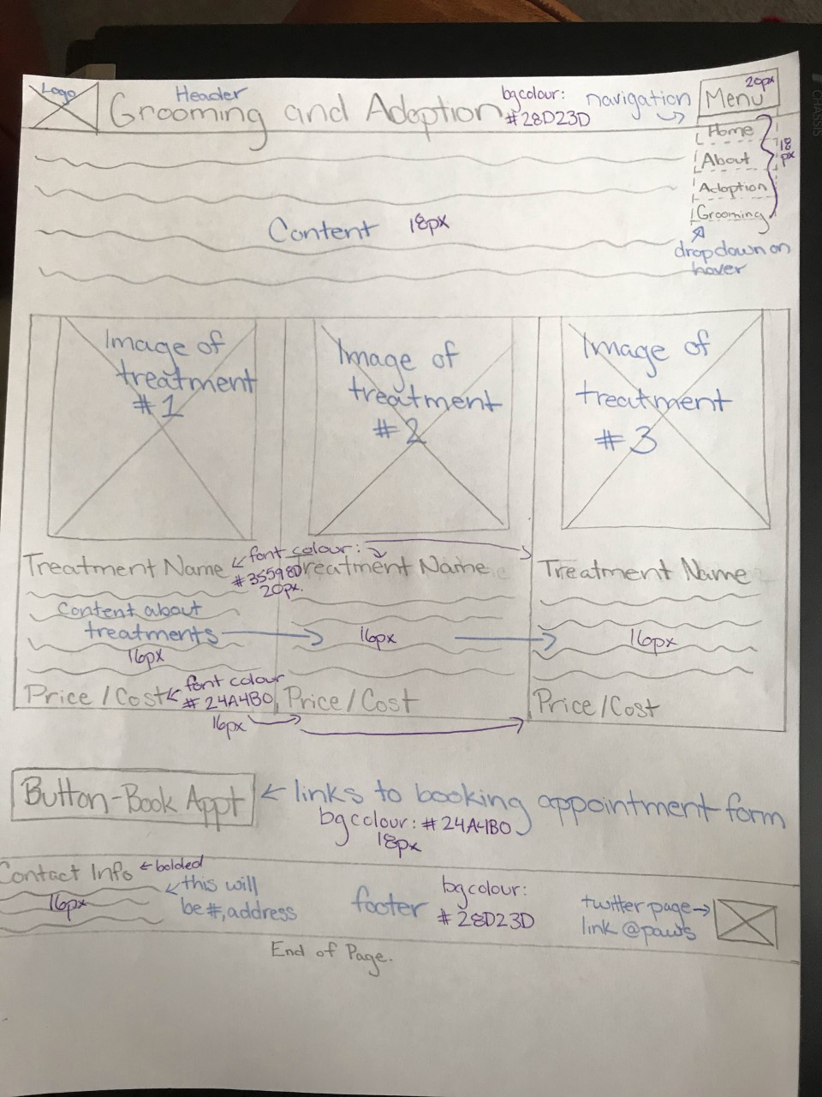

**Appointment Mockup:**

